Web Search & Mining Report

118033910115 刘涛

118033930145 雷沁欣

118033930160 徐玉鹏

General Info:

Our final project for the web search & mining class is to crawl the weibo blogs of 100 bloggers of weibo about media and then build a search engine for the contents we crawled.

The data we crawled and the indexes we built for the data have been stored in the MongoDB database. And the system have been deloyed on the web.

1. Crawler

Reptilian tools

Python Scrapy is a reptilian tools which can get structed data from website.We are using this tool to get our first data.

Frist,we need to register a weibo account,then get it id ,my id is 7141250571 and follow 100 newers. The photo below is my following:

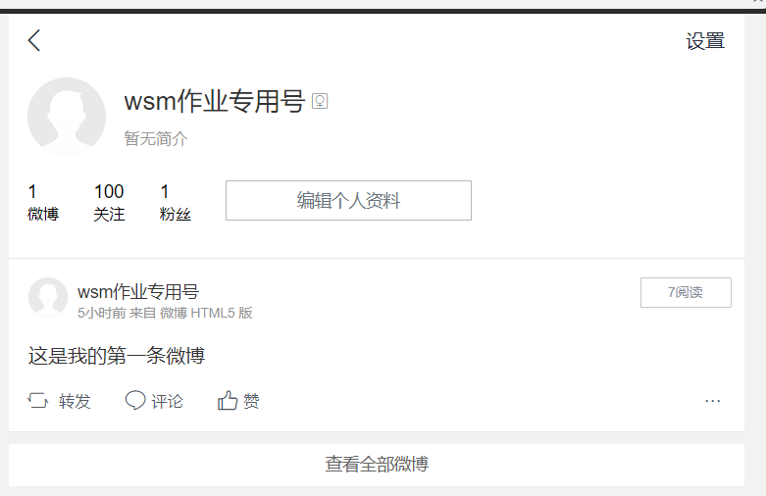

Then,we change python scrapy logic into following. (1)get the list of my following; (2)get the list of following users’ blog one by one; (3)get every blog’s comments . The main logic is the following:



Finally, we will get enough data after 20 days scrapying with 268.4MB data size.



The whole statistics of our data is the following:





We can clearly see that 100 bloggers are downloaded from the weibo.



The most import part of tweet content in our dataset is tweets table. This table record about 1.1 million blogs.



We use post man to adjust our api.

2. indexer

we build reverted index for the weibo, the comments and hashtag separately

* word segmentation

we use the Jieba Toolkit to do the chinese word segmentation.

* vocabulary building

when we go over the whole corpus , we constructed a vocabulary for the whole corpus.

* posting list

we go over the whole corpus to build the posting list for each word in the vocabulary

* stop words vocabulary building

when we construct the posting list for each word , if the length of the posting list has gone very big , we add this word to the stop_word list , which we will manully decide later if we really want to set aside this word when we build the reverted index

1. ranker

For the ranker , we took into two metrics into account :

1. number of comments
2. the TF-IDF score

In information retrieval, tf–idf or TFIDF, short for term frequency–inverse document frequency, is a numerical statistic that is intended to reflect how important a word is to a document in a collection or corpus.It is often used as a weighting factor in searches of information retrieval, text mining, and user modeling. The tf–idf value increases proportionally to the number of times a word appears in the document and is offset by the number of documents in the corpus that contain the word, which helps to adjust for the fact that some words appear more frequently in general.

* + TF(Term Frequency): we compute the TF value for each word in each document and store the value in the posting list
  + IDF(Inverse Document Frequency): we compute the IDF value for each word in the vocabulary

4. front end

Effect Picture:

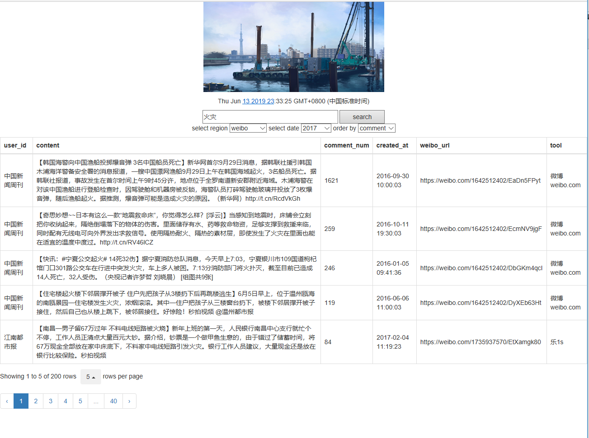

In the front end, we use html+javascript to set up the website. Hypertext Markup Language (HTML) is the standard markup language for documents designed to be displayed in a web browser. It can be assisted by technologies such as Cascading Style Sheets (CSS) and scripting languages such as JavaScript.

Web browsers receive HTML documents from a web server or from local storage and render the documents into multimedia web pages. HTML describes the structure of a web page semantically and originally included cues for the appearance of the document.

JavaScript often abbreviated as JS, is a high-level, interpreted programming language that conforms to the ECMAScript specification. JavaScript has curly-bracket syntax, dynamic typing, prototype-based object-orientation, and first-class functions.

<head>

<meta charset="utf-8">

<meta http-equiv="X-UA-Compatible" content="IE=edge,chrome=1">

<link href="https://cdn.staticfile.org/twitter-bootstrap/3.3.7/css/bootstrap.min.css" rel="stylesheet">

<script src="https://cdn.staticfile.org/jquery/2.1.1/jquery.min.js"></script>

<script src="https://cdn.staticfile.org/twitter-bootstrap/3.3.7/js/bootstrap.min.js"></script>

<script type="text/javascript" src="https://cdn.bootcss.com/jquery/3.4.1/jquery.min.js"></script>

<script type="text/javascript" src="https://cdn.bootcss.com/bootstrap-table/1.14.2/bootstrap-table.min.js"></script>

<link href="https://cdn.bootcss.com/bootstrap-table/1.14.2/bootstrap-table.min.css" rel="stylesheet">

<title>A Weibo Search Engine</title>

<style type="text/css">

.page{

text-align: center;

margin-top: 50px;

}

.page a{

text-decoration: none;

border: 1px solid #f9d52b;

padding: 5px 7px;

color: #767675

}

.page span{

text-decoration: none;

border: 1px solid #f9d52b;

padding: 5px 7px;

color: #767675

}

</style>

<meta name="description" content="">

<meta name="keywords" content="">

<link href="" rel="stylesheet">

</head>

Asynchronous JavaScript and XML(AJAX) is used to implement a request request to the server. Ajax is a set of web development techniques using many web technologies on the client side to create asynchronous web applications. With Ajax, web applications can send and retrieve data from a server asynchronously (in the background) without interfering with the display and behavior of the existing page. By decoupling the data interchange layer from the presentation layer, Ajax allows web pages and, by extension, web applications, to change content dynamically without the need to reload the entire page.In practice, modern implementations commonly utilize JSON instead of XML.

Ajax is not a single technology, but rather a group of technologies. HTML and CSS can be used in combination to mark up and style information. The webpage can then be modified by JavaScript to dynamically display—and allow the user to interact with—the new information. The built-in XMLHttpRequest object, or since 2017 the new "fetch()" function within JavaScript is commonly used to execute Ajax on webpages allowing websites to load content onto the screen without refreshing the page. Ajax is not a new technology, or different language, just existing technologies used in new ways.

if (window.XMLHttpRequest)

{

xmlhttp=new XMLHttpRequest();

}

else

{

xmlhttp=new ActiveXObject("Microsoft.XMLHTTP");

}

xmlhttp.onreadystatechange=function()

{

if (xmlhttp.readyState==4 && xmlhttp.status==200)

{

var str=xmlhttp.responseText;

var obj=JSON.parse(str);

var table=document.getElementById("table");

$("#table").bootstrapTable('load',obj.data);

table.style.display= "table";

}

BootstrapTable is used to render data and implement paging. Bootstrap is a free and open-source CSS framework directed at responsive, mobile-first front-end web development. It contains CSS- and (optionally) JavaScript-based design templates for typography, forms, buttons, navigation and other interface components.